INCA MINERALS
Inca is currently undertaking a maiden drilling campaign at its Riqueza Zn-Ag-Pb project in Peru. The campaign comprises three phases of drilling for a total of approximately 48 holes and 14,000 metres of drilling (which can be extended to 16,800m automatically under the conditions of the granted DIA drill permit).
As at July 2017, 11 holes have been completed for a total of 2,063.7m.
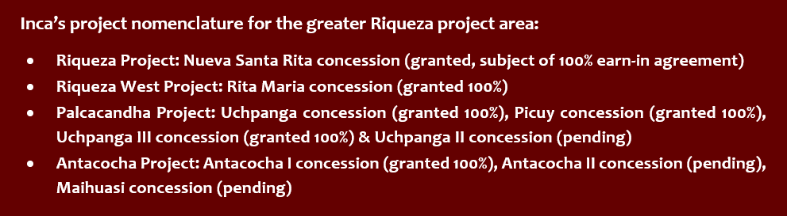
The company is very pleased to also report that several of its concession applications adjacent to Riqueza are now starting to be granted. Inca’s land holding is greatly increasing, with the greater Riqueza project area now comprising the Riqueza Project, the Riqueza West Project, the Palcacandha Project and the Antacocha Project.
Running parallel to the drilling campaign, the company is continuing its reconnaissance exploration programs across the greater Riqueza project area. Results are to date very encouraging – READ FURTHER BELOW
Inca’s second Zn-focussed project Cerro Rayas, has also been in the news. Very strong >40% Zn values were returned from sampling one of two mine workings occurring on the project. And now, an additional concession has been added to the project, which a third mine working.
KEY TAKE-AWAYS
- Currently drilling at our Zn-focussed Riqueza Project which hosts >100 individual Zn-Ag-Pb-(Au) occurrences.
- Circa 50% of all surface samples at Riqueza averages 13% Zn, 311g/t Ag, 16% Pb.
- Riqueza is a replacement deposit associated with a mineralised intrusive system (NOTE: Eight mines and deposits within 50km are intrusive related).
- Epithermal Au and Skarn Cu now recognised within the greater Riqueza project area.
- Huge new targets generated within the greater Riqueza project area.
- BHP have taken a ground position adjacent to Riqueza.
- Exciting second Zn-focus project produces head-line Zn grades – a third mine working becomes part of the project.
- The SP experienced a >500% increase during pre-drilling exploration activities.
- Zinc prices continue to out-perform other metals as production is squeezed and warehouse levels fall.
- Cornerstone investors include Chinese smelter interests and one of the largest resource funds in the world, RCF.
Inca Minerals Managing Director, Mr Ross Brown said “Since April 2016, when we first announced the acquisition of Riqueza, we have discovered over 100 new occurrences of Zn-Ag-Pb-(Au) mineralisation at Riqueza, including new structures, numerous veins, mantos and breccias. We are currently drilling these targets. At the same time, we are generating even more targets on a much larger scale, incorporating the new concessions now being granted to Inca that surround the original Riqueza Project area.”
“…we are generating even more targets on a much larger scale.”
Since early 2016, Riqueza has grown from a small project with a handful of known Zn-Ag-Pb occurrences into a very substantial multi-project property with innumerable Zn-Ag-Pb-Au-Cu occurrences. From two prospects, Humaspunco and Uchpanga, there are now six prospects, now including Pinta, Pampa Corral, Colina Roja and Alteration Ridge.
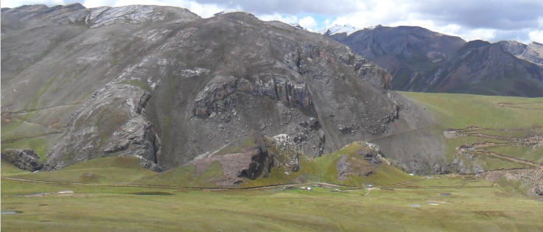
The Humaspunco-Pinta combined prospect area, with an approximate area of 2,500m x 800m, hosts the majority of the replacement-style Zn-Ag-Pb veins, breccias and mantos and is currently (July 2017) where the drilling is occurring. Drilling to date has successfully intersected the HV-series of mineralised veins and the manto sequence. The HV-veins have been projected to depths of 400m. Drilling is continuing at Humaspunco.
The Uchpanga Prospect, some 2.5km south of Humaspunco, host a number of small mine workings located along a 750m gossan containing Zn-Ag-Pb-Au epithermal-style mineralisation. A vein/dyke, which was the subject of past mining at the Rita Maria mine working (the largest at Uchpanga) was sampled by Inca and returned +3g/t Au and +1,000g/t Ag. Recent first pass drilling identified low grade stratiform mineralisation. Further drilling is planned for Uchpanga.
The four new prospects are elevating Riqueza to new heights, pushing expectations beyond high grade veins and mantos to something at a much different scale.
“The greater Riqueza project has morphed into a double-play” says Mr Brown. “The high-grade veins, breccias and mantos, which occur at Humaspunco, are very tangible, well within the purview of a junior explorer such as Inca. But something else is brewing here, something that has the potential to re-rate Riqueza significantly. We’re beginning to peel back the layers of something that is attracting the likes of BHP to our borders. It’s the discovery of epithermal gold and skarn copper.
“…peel back the layers of something that is attacking the likes of BHP to our borders.”
Running parallel to drilling, we’ve discovered intrusive stocks, hitherto unknown at Riqueza, skarn Cu mineralisation and epithermal Au-Ag-Cu mineralisation. These are vital parts of a large mineralised intrusive-related system.
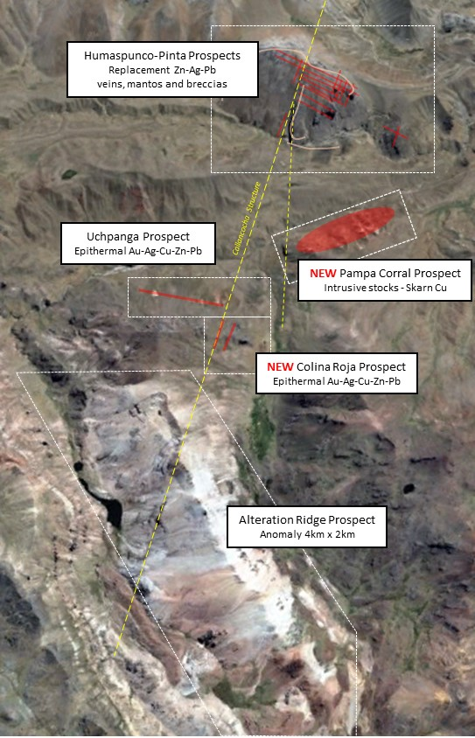
The Colina Roja and Alteration Ridge Prospects are located in Inca’s new concessions. The latter hosts a 4km x 2km satellite anomaly believed to relate to pervasive epithermal mineralisation. At the foothills of Alteration Ridge sits Colina Roja. “This new prospect hosts gold, silver and copper, as well as high grade zinc and lead.”
There are eight mines within 50km of Riqueza that are intrusive-replacement deposits. These define a prolific mineral-belt, within which the greater Riqueza prospect sits.
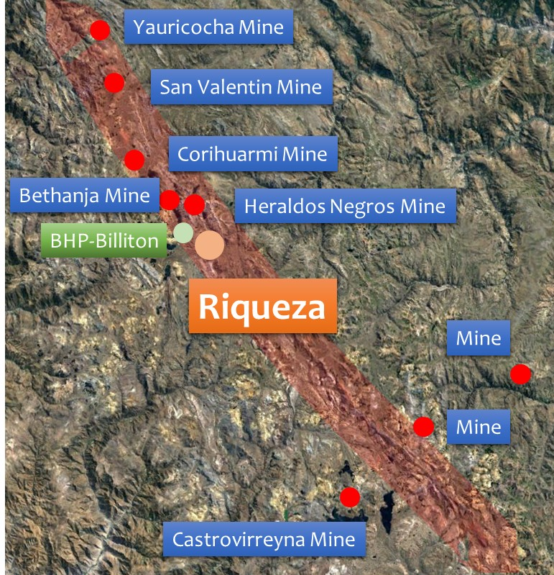
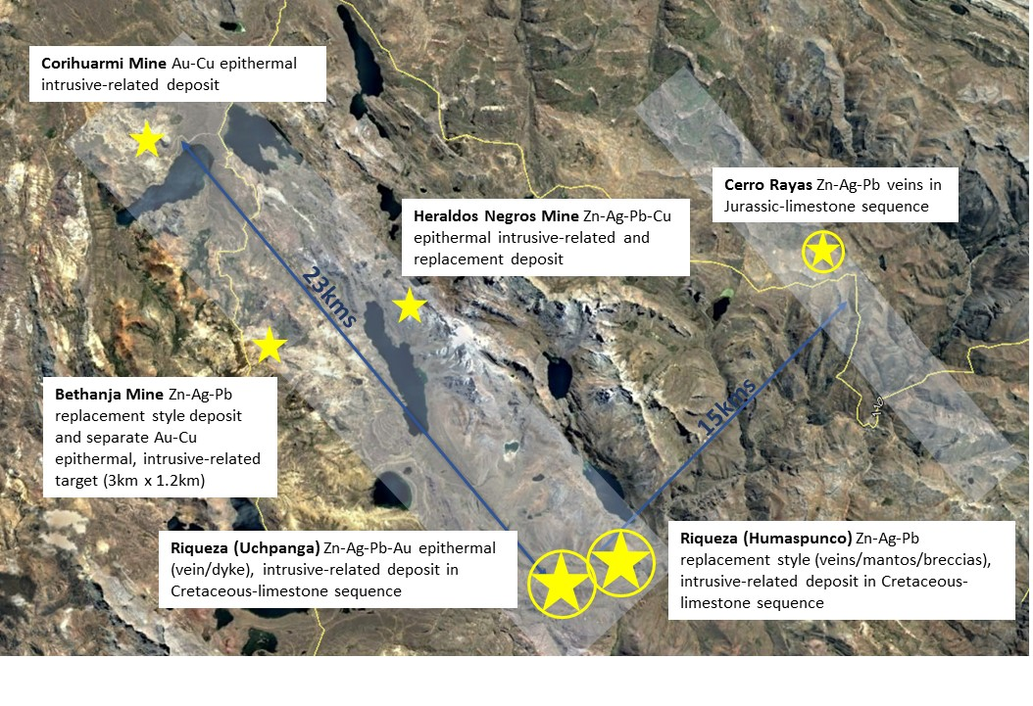

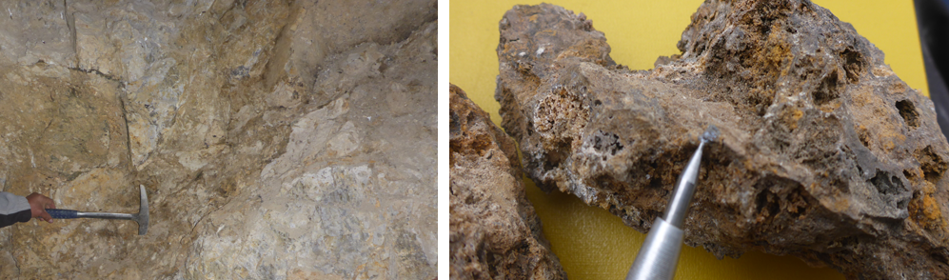
Inca’s second Zn-focussed project Cerro Rayas is also looking good. Rock chip sample assay results show very strong Zn mineralisation associated two mine workings located within the project area, Vilcapuquio and Huari (the former pictured below). Peak values include 42.77% zinc (Zn); 258g/t silver (Ag); 26.1% lead (Pb).
Inca has recently consolidated its land holding at Cerro Rayas. By doing this the project now covers a third mine working, Torrepata, the largest of the three (pictured below). Peak Zn value from sampling here is 41.59 % Zn.
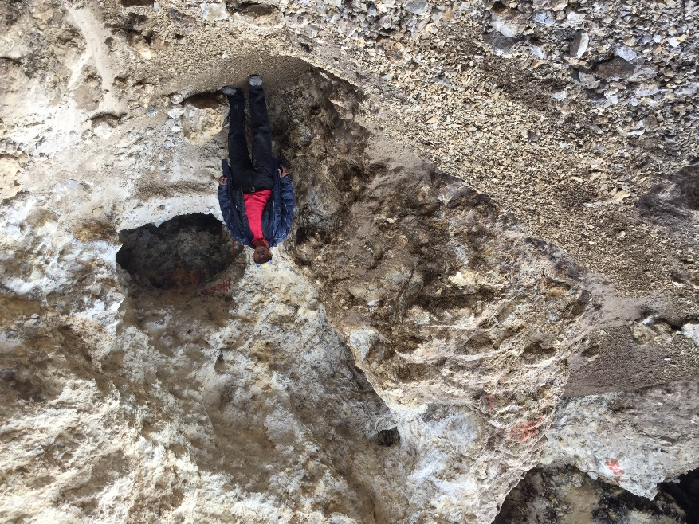
INCA’S PURPOSE
It is the intention of Inca to develop its Riqueza Project (and other Zn projects it has and may acquire) using best practice exploration methods with the “end-game” of defining an economic resource and commencing exploitation. With respect to Riqueza, we believe an Exploration Target (JORC 2012 Chapter 17-19) can be achieved with the current DIA drilling. We also believe a mineral resource (JORC 2012) can be achieved within a 2 to 5 year time frame.
The company continues to strive for exploration excellence and to maximise shareholder value through discovery and development. “We will not shirk from difficult decisions, nor take for granted shareholder support. We adhere to foundation best practise principles in exploration, social and environment management.”
INCA’S PROJECTS
Inca’s exploration focus is on the discovery and delineation of economically important high grade Zn-Ag-Pb±Au±Cu deposits in Peru―with special emphasis on Zn. The Riqueza Project , as well as the Cerro Rayas Project, both contain high grade Zn-Ag-Pb mineralisation and have substantial upside potential.
PERU
Peru plays a major role in the global zinc market. It hosts a number of top 20 global zinc mines, produces the third highest amount of zinc in the world (after China and Australia) and has the third largest Zn reserve in the world (after Australia and China). Antamina (in Peru) is the sixth largest zinc mine in the world and is owned by BHP-Billiton, Xstrata, Teck and Mitsubishi.
Peru’s exports reached a total of $41.2 billion at the end of 2013. Its main exports were zinc, along with other minerals such as copper and gold. These mining exports accounted for 55.2% of the country’s economic exports. The mining industry accounts for 24% of Peru’s foreign investment. It is estimated that the current value of mining investments in Peru totals around $10 billion.
POLYMETALLIC REPLACEMENT DEPOSITS
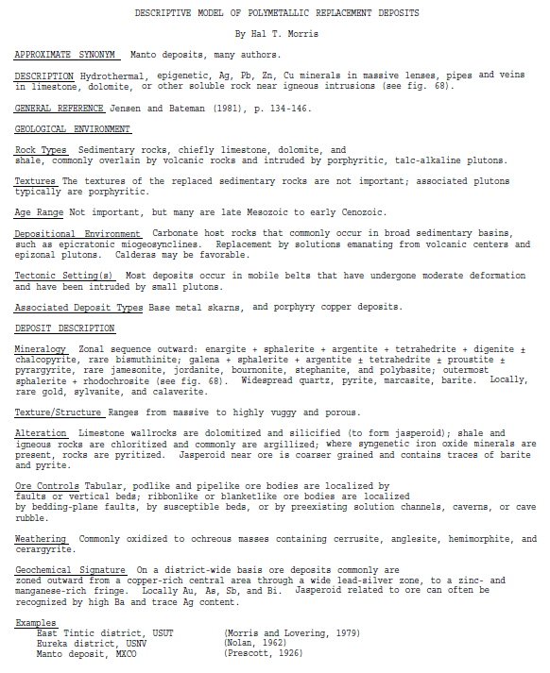
The descriptive model of Polymetallic Replacement Deposits is copied and pasted from USGS Bulletin 1693 (1986). Many of the attributes described below are apparent at Riqueza.
INCA’S PEOPLE
Inca has built a passionate team of Perth and Peru based professionals. Our Peru-based team comprises leaders in geological interpretation, exploration planning and execution, social, community and environmental management. Our Perth-based management adhere to the highest standards of corporate governance and compliancy regulations. It is worth highlighting that our three-person board is un-changed since early 2012.
INCA’S PERFORMANCE
In a crowded junior resource sector, Inca discerns itself by its projects, its people and its performance. “It’s the 3-P’s” says Mr Brown. “Add Peru and persistence – it becomes the 5-P’s. We’ve been operating in Peru now since 2011 (pre-listed and listed status). We’ve seen companies come and go. We are still here. Why? Well that’s simple. Peru is full of metal. It scores highly in global production in Ag, Cu, Zn, Pb and Au. It scores highly in global exploration spend. We consider Peru a place where mineral discoveries are possible and indeed likely.”
In 2013, the company discovered a large porphyry system at Chanape. The company mapped and sampled the surface and drilled the targets below. World expert opinion based on the sum-total of all our work concluded that the Cu part of the porphyry was beyond economic exploitation. We moved on. “Not a hole too few not a hole too many” says Mr Brown. “This is the process of exploration. It is a process of discovery. We’ve made discoveries in the past, and we shall do so in the future”.
“We’ve made discoveries in the past, and we shall do so in the future.”
Move on 24 months to the current time (July 2017)―we have commenced maiden drilling at the Riqueza Zn-Ag-Pb-(Au) Project and greatly expanded it at the same time and we’ve consolidated the land holding at Cerro Rayas, ready to spring-board into exploration there too.
WHAT’S NEXT
“We’ve had two +10-baggers since operating in Peru” says Mr Brown. “The first came about after DDH-001 at Chanape―drilling into a porphyry for the first time. The second came about through sustained success as Riqueza―more and more occurrences of strong mineralisation.
Now we are in full swing with drilling at Riqueza and we will be ramping up surface exploration at Palcacandha and Cerro Rayas! There’s plenty of news to come.”
*****

